Aircraft Dimensions | KR 020 TOPAZ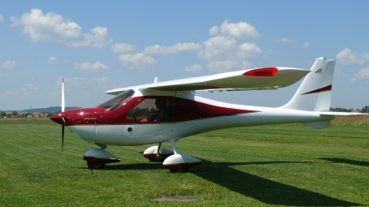
Construction Type | Full Vinyl-Ester Composite
Wing Span (m) | 10.58
Length (m) | 5.95
Height (m) | 2.35
Verified Empty Weight (kg) | 310kg
MTOW (kg) | 560kg

Engine & Propeller Detail | KR 020 TOPAZ
Engine | Rotax 912 uls 100hp
Propeller | PESZKE 66inch 3-blade Composite

Design Speeds | Km/h | Knots
VC | 200 | 108
VNE | 240 | 130
VSO | 65 | 35

Performance Values | Metres | Feet
Climb Rate @ Sea Level | 8m/s | 1550 ft/min
Take-Off Distance | 70m | 230ft
Landing Distance | 100m | 328ft

Technical Specifications | KR 020 TOPAZ
Fuel Capacity | 86 Litre Wing Tanks
Fuel Consumption | 13 Litres/Hour
Economy Range (km) | 1300km Without Reserve

Standard Equipment Levels | KR 020 TOPAZ
Flying Instrumentation | 79mm - ASI; ALT; VSI 57mm - Panel Mounted Compass; Slip, Flap & Trim Position Indicators, Strobe, Left/Right Position Lights.
Mandatory AOA Alarm For PPL Training Required | Included
Engine Instrumentation | RPM; Oil Temperature; Oil Pressure; 2 x CHT; Fuel Level Gauges; Voltmeter; Hobbs.
Avionics | MGL V6 Transceiver With Dual PPT’s Sandia Mode S Transponder
Exterior Paint | White 2K (Inc. Matched Spinner)
Interior Paint | Grey or Light Brown
Wheels & Spats | 500-5 6 Ply + Painted Wheel Spats
Brakes | Hydraulic Hand Lever Operated
Seats (Leather Bolstered Optional) | Standard Textile Upholstered
Safety Belts | Four Point (Red/Black/Blue)
Wing Step Option | N/A
Canopy Cover Option | Optional
Tow Bar Option | Optional

Costs | KR 020 Topaz
Total Euro Cost As Specified Above Assuming Six (6) ‘Ready to Fly’ Factory Tested Complete Aircraft | 56 000 Euro  (R950 972.00 @ R 16.98/1.00 Euro)
Insured Shipping Charges | 1 x 20ft & 1 x 40ft Container R 150 000.00 (Excluding Customs VAT & Duties)
Manufacturing Terms: | Seven Months From Deposit Date
Payment Terms: | 50% Deposit On Confirmed Order 50% Balance Payable Prior To Shipping Customs VAT, Duties & Shipping Are Only Payable On Delivery

